History of Labor and Labor Movements in the United States and Europe

Fall Semester, 2018
Section 1 (3:00-3:50 p.m., Monday, Tuesday, Thursday)
Professor: Dr. Brian J. Hale
E-Mail Address: bhale@uwsp.edu; Office: CCC 465.
Office Hours: Tuesday, 2:00-2:45 p.m., Thursday, 4:00-5:00 p.m., and by prearranged appointment.

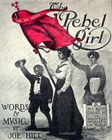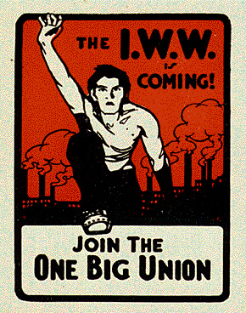
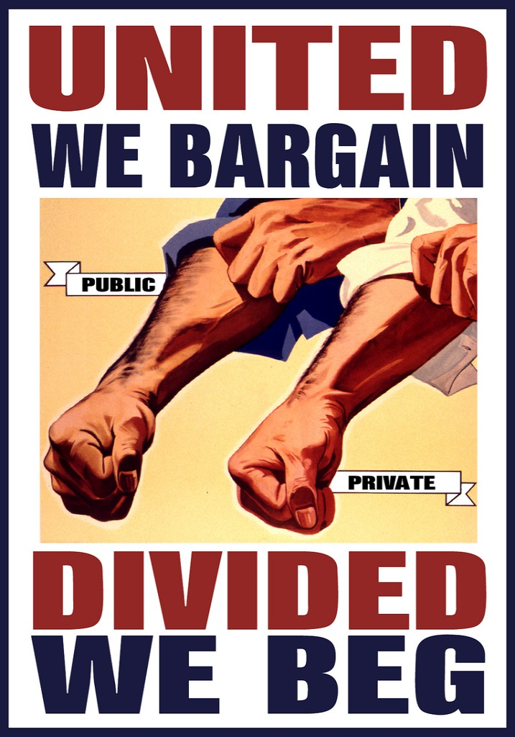
Purpose of the Class:
The purpose of this class is to provide you with a comparative overview of the history of labor and labor movements in the United States and Europe from the eighteenth century to the present. The course will not only consider the rise of organized labor but the experience of the non-organized majority of the working class. It will focus on the political and social interactions of ethnicity, race, gender, and social class. The themes we will explore include bond and free labor in the colonial era; the impact of the industrial revolution on American and European workers; the tension between reform and radical trade unionism in the late nineteenth-century; immigration and the working class in the late nineteenth century; the global crisis ignited by World War I and the suppression of labor movements; revolution after World War I; the impact of scientific management on the nature of work; the expansion and democratization of the labor movement in the United States during the 1930s and 1940s; the elimination of labor movements and the subordination of labor in Nazi Germany and Fascist Italy; racial minorities and labor; the role of labor since World War II; new immigrants and organizations; the decline of labor movements in the United States and Europe; and prospects for labor and labor movements in the future. Lectures, readings, workshops, discussions, quizzes, and exams will help you understand major themes of the course.
It is important to note that history always requires constant rethinking and rewriting. For example, changes in perspective recently have made it possible for historians to link the history of the American and European working classes to wider developments in the world. Another new perspective emphasizes that the history of labor is the story of an ongoing process, not a finished result with one fixed meaning. There was not one American or European system of labor or labor movement from the eighteenth century to the present. Instead, the history of labor’s development must be seen in a broad, global context that reveals the cross-cultural interactions fundamental to the shaping of American and European politics, societies, cultures, and economies. The course also aims to provide a chronological framework to help everyone understand how labor and labor movements have influenced the political, social, cultural, economic, and religious histories of various places over time. A solid chronological and comparative framework furnishes the class with a certain number of benchmarks to make the material easy to grasp. The chronological and comparative approach also helps everyone to see the interconnections among varieties of historical experiences in the United States and in Europe.
__________________________________________________________________________________________
Intended Outcomes:
This course is designated as “Historical Perspectives” under the Investigation Level of the General Education Program (GEP). Building on the skills and knowledge acquired from the Foundation Level, the GEP courses in Historical Perspectives are “meant to encourage students to acquire broad knowledge of the world in which they live, as well as the various disciplinary methods by which this knowledge is produced.” The course’s intended learning outcomes will directly align with GEP outcomes.
The GEP Historical Perspectives Learning Outcomes are the following:
- Describe events from past cultures, societies, or civilizations.
- Recognize the varieties of evidence that historians use to offer diverse
perspectives on the meaning of the past.
- Identify the role of human agency in shaping events and historical change.
- Explain historical causality.
- Evaluate competing historical claims that frequently inform the present.
Through this course, students will improve their ability to:
- Employ foundational concepts, themes, places, and individuals in describing
American and European labor histories while recognizing and using key terms in all assignments.
- Analyze primary sources to explain historical causality in history.
- Use primary sources to identify the role of individuals and groups in labor history.
- Read critically to identify scholarly arguments in secondary works.
- Listen critically in lectures to identify scholarly arguments about labor history.
_________________________________________________________________________________________

__________________________________________________________________________________________
Required Texts:
E-Reserve readings.
Eileen Boris, ed., Major Problems in the History of American Workers, 2nd ed. (Boston: Cengage, 2003).
Other Books:
Jo Ann E. Argersinger, The Triangle Fire (Boston: Bedford/St. Martin’s, 2016).
John Steinbeck, In Dubious Battle (New York: Penguin, 2006).
George Orwell, Homage to Catalonia/ Down & Out in Paris and London (Boston: Houghton Mifflin, 2010).
Suggested Reading:
Mary L. Kelley, Understanding and Answering Essay Questions (Englewood Cliffs, 1994).
Mary Lynn Rampolla, A Pocket Guide to Writing in History, 4th ed. (Boston and New York, 2004).
William Zinsser, On Writing Well (New York, 1976).
Reading Assignments:
The reading assignments from Boris’s collection of documents, as well as from a wide variety of E-Reserve readings, will be posted in Desire to Learn under our course title on the weekend before the start of each week of classes. You can rent Boris’s book at the Dreyfus University Center bookstore. The E-Reserve readings are embedded in the course content section of Desire to Learn. The “Other Books” are by writers who made important observations about labor and labor movements in Europe and the United States. They can be purchased at the Dreyfus Center bookstore or from various online retailers. Be sure to get the correct edition of each book. The “Suggested Reading” list provides you with books about how to take essay exams and write essays. Copies of the books by Rampolla and Zinsser are on two-hour reserve in the library. Kelley’s short pamphlet is available as a link in Desire to Learn.
Workshops, Discussions, Exams, and Essays:
Workshop and discussion sections comprise an essential and integral part of our course: a workshop where you can deepen your understanding of the readings and the problems they raise; a forum where you can clarify your thinking and express your ideas about labor and labor movements; a collective (whole-class) discussion where you can reflect together about the important issues of the readings. Each workshop and discussion will gravitate around the problems raised by the reading assignments and lectures. You must complete a writing assignment about the readings each week (20.0 points each). The form which you must complete about the weekly reading assignments can be found at the end of this syllabus. A digital copy of the assignment is due in the course Dropbox of Desire to Learn by 11:00 p.m. every Wednesday. Bring a hard copy to class every Thursday so that you can participate in the workshop. If you fail to bring the hard copy to class, you will lose participation and discussion points for that day. No late digital copies will be accepted.
You will take two exams during the semester. Each exam will consist of three parts: (1) one essay question (30.00 points) based on the assigned readings and the workshop and discussion sections; and (2) two essay questions (70.0 points) based on the course lectures. Each exam is worth 100.0 points.
You will write a short essay about one of the “Other Books” (50.0 points). The essay must be at least two, single-spaced pages long. If you write less, you will not earn all of the points. It must be typed with 1 inch margins at the top, sides, and bottom. Type a cover page with your name and the title of the essay on it. Do not repeat that information on the first page. The essay must discuss the thesis of the work. You will upload the
essay to the Dropbox in Desire to Learn by 11:00 p.m. on Thursday, December 6.
Important Dates:
Exam I on Thursday, October 18.
Essay due in Dropbox by 11:00 p.m. on Thursday, December 6.
Final Exam on Tuesday, December 18 from 12:30-2:30 p.m. in CCC 304.
Exam Grades:
Exam I: 100.0 points 90 -100% = A
Exam II: 100.0 points 80 - 89% = B
Discussion: 280.0 points 70 - 79% = C
Essay: 50.0 points 60 - 69% = D
Total: 530.0 points 0 - 59% = F
__________________________________________________________________________________________
Exam Grading Criteria:
A: Demonstrates mastery of historical information (ideas, names, places, dates) and provides a
knowledgeable interpretation of that information.
B: Demonstrates a command of historical information but provides an ineffective interpretation.
C: Demonstrates a command of historical information but lacks any kind of interpretation.
D: Demonstrates a brittle command of historical information and lacks completely any kind of
interpretation.
F: Demonstrates inaccurate historical knowledge and lacks completely any kind of interpretation.
UWSP Rights and Responsibilities:
UWSP values a safe, honest, respectful, and inviting learning environment. In order to ensure that each student has an opportunity to succeed, a set of expectations have been developed for all students and instructors. This set of expectations is known as the Rights and Responsibilities document, and it is intended to help establish a positive living and learning environment at UWSP. For more information, go to:
http://www.uwsp.edu/stuaffairs/Pages/departments/rightsResponsibilities.aspx.
The Rights and Responsibilities document also includes the policies regarding academic misconduct, which can be found in Chapter 14. A direct link can be found here:
http://www.uwsp.edu/stuaffairs/Documents/RightsRespons/SRR-2010/rightsChap14.pdf.
__________________________________________________________________________________________
Americans with Disabilities Act:
The Americans with Disabilities Act (ADA) is a federal law regarding educational institutions to provide reasonable accommodations for students with disabilities. For more information about UWSP’s policies, check here:
http://www.uwsp.edu/stuaffairs/Documens/RightsRespons/ADA/rightsADAPolicyinfo.pdf
If you have a disability or require classroom and/or exam accommodations, please register with the Disability Services Office and then contact me at the beginning of the course. For more information, please visit the Disability and Assistive Technology Center, located on the sixth floor of the Learning Resource Center (the library). You can also find more information here:
http://www4.uwsp.edu/special/disability/.
__________________________________________________________________________________________
Tutoring and Learning Center:
If you need help with the assigned readings and writing, visit the Tutoring and Learning Center in the basement of the library. The staff will help you, and their services are free!! You can call to make an appointment at (715-346-3568) or you can take a look at the services they offer on their webpage at: http://www.uwsp.edu/tlc/Pages/writingReadingTutorials.aspx. Needless to say, you can also get help from me during my office hours or at a prearranged time.
__________________________________________________________________________________________
Regulations:
- All societies have norms, and it is therefore important for you to abide by the rules of conduct in this class.
- Value inclusivity at all times.
- You must take all of the exams and complete each section of the exams to pass the course. No early final exams will be given.
- You must read one of the books listed under “other required works” and upload an essay about it to the Drop Box in Desire to Learn to pass the course.
- Please maintain respect in the classroom. Talking to classmates during lecture, reading newspapers or books, working on materials for other classes, looking at your phone, sleeping, and packing up before the end of class are examples of disrespectful behavior.
- Do not leave the room in the middle of class, because it is disruptive to the instructor and other students. You are expected to spend the entire 50 minutes in class. Any exceptions to this rule must be approved by the instructor prior to the class period. Appointments are not a valid excuse to leave class early.
- Please remember to turn off all technology (cell phones, etc.) during class. Recording lectures and using smart pens is prohibited.
- Attendance is part of your grade!! If you miss 5 or more classes (11%) during the semester, your grade will drop by 10%. If you miss 8 or more classes (18%) during the semester, your grade will drop by 20%. If you miss 10 or more classes (22%), you will fail the course. The only excused absences are for your personal hospitalizations, deaths in your immediate family, and university-related functions. Appropriate documentation must be provided to me in each case.
- You are responsible for signing the attendance sheet each day. If you do not sign the attendance sheet, you will be listed as absent.
- No instance of academic misconduct, such as plagiarism or cheating, will be tolerated. They are serious offenses against fellow students and the university community.
- Posting instructor-created course materials onto course-sharing websites directly violates the instructor’s copyright to his academic materials. These materials are provided for your convenience as an aid to learning. Permission to post instructor-created material on any such site is unequivocally denied.
_________________________________________________________________________________________
Additional Notes:
- Extra credit is available upon request. Extra credit will be offered at the discretion of the instructor. No extra credit will be granted during the last two weeks of the semester. If you miss more than 4 classes during the semester, you will not receive any type of extra credit points.
- If you require special accommodations in order to meet the requirements of this course, please contact me during the first week of the semester.
- This syllabus is subject to change throughout the semester.
__________________________________________________________________________________________
Bibliography of Books Used in Weekly Reading Assignments:

Calling Home: Janet Zandy, ed., Calling Home. Working-Class Women’s Writings (New Brunswick:
Rutgers University Press, 1993).

Chavez: Frank Bardacke, Trampling out the Vintage. Cesar Chavez and the Two Souls of the
United Farm Workers (London: Verso, 2011).

Essential Lenin: Ernst Fischer, ed., The Essential Lenin (New York: Herder and Herder, 1972).

Evolutionary: Eduard Bernstein, Evolutionary Socialism (New York: Schocken, 1970).

False Promises: Stanley Aronowitz, False Promises. The Shaping of American Working Class
Consciousness (New York: McGraw Hill, 1973).

Fourier: Jonathan Beecher, ed., The Utopian Vision of Charles Fourier (Boston: Beacon, 1971).

Freedom’s Frontier: Stacey L. Smith, Freedom’s Frontier. California and the Struggle over Unfree Labor,
Emancipation, and Reconstruction (Chapel Hill: University of North Carolina Press,
2013). Available at UWSP library online.

French Revolution: Roger Price, ed., Documents on the French Revolution of 1848 (New York: St. Martin’s
Press, 1996).

French Worker: Mark Traugott, ed., The French Worker. Autobiographies from the Early Industrial Era
(Berkeley: University of California Press, 1993).

German Worker: Alfred Kelly, ed., The German Worker. Working-Class Autobiographies from the Age
of Industrialization (Berkeley: University of California Press, 1987).

Joy: Tera W. Hunter, To ‘Joy My Freedom. Southern Black Women’s Lives and Labors
After the Civil War (Cambridge: Harvard University Press, 1997).

Jungle: Thaddeus Russell, Out of the Jungle. Jimmy Hoffa and the Remaking of the American
Working Class (New York: Knopf, 2001).

Kolhatkar Sheelah Kolhatkar, “Dark Factory,” The New Yorker (October 23, 2017), pp. 69-81.

Little Man: Hans Fallada, Little Man, What Now? (New York: Simon and Schuster, 1933).

Making: E. P. Thompson, The Making of the English Working Class (New York: Vintage, 1963).

Mass Strike: Rosa Luxemburg, The Mass Strike, the Political Party, and the Trade Unions, trans.
Patrick Lavin (New York: Harper Torchbooks, 1971).

Nazism: Jeremy Noakes, ed., Nazism. A Documentary Reader, Vol. 2: State, Economy and
Society, 1933-1939 (Exeter: University of Exeter Press, 2008).

New Deal: Lizabeth Cohen, Making a New Deal. Industrial Workers in Chicago, 1919-1939
(New York: Cambridge University Press, 1990).

Problems: Eileen Boris, ed., Major Problems in the History of American Workers, 2nd ed.
(Boston: Cengage, 2003).

Rainbow: George Lipsitz, Rainbow at Midnight. Labor and Culture in the 1940s (Urbana:
University of Illinois Press, 1994).

Reader: Daniel J. Leab, The Labor History Reader (Urbana: University of Illinois Press, 1985).

Transnational: Roland Erne, European Unions. Labor’s Quest for a Transnational Democracy
(Ithaca: Cornell University Press, 2008).

Western Past: Merry E. Wiesner, ed., Discovering the Western Past. A Look at the Evidence, 6th ed.,
Vol. 2: Since 1500 (Boston: Houghton Mifflin, 2008).

Wigan Pier: George Orwell, The Road to Wigan Pier (New York: Harcourt, Brace, Jovanovich,
1958).

Women: Meridel Le Sueur, Women on the Breadlines (New York: West End Press, 1977).

__________________________________________________________________________________________
Writing Assignment for Workshop and Discussion Sections:
Please use the following format when completing your writing assignment for the workshop and discussion sections. Bring a hard copy to class and to upload a digital copy to the Dropbox in Desire to Learn!

__________________________________________________________________________________________
Student Name:
Name of Reading:

__________________________________________________________________________________________
Summarize the reading assignment in one, single-spaced paragraph:

__________________________________________________________________________________________
Explain how the reading assignment informs us about labor and/or the labor movement:

__________________________________________________________________________________________
Write two (2) discussion questions which will be posed to your workshop group or the class. The questions
should not “quiz” your classmates about content. Instead, the questions should be about what kind of ideas the authors of the reading assignments were trying to express. You should create “critical thinking” questions!

